App.js
import logo from "./logo.svg";
import React, { useState } from "react";
import "./App.css";
function App() {
const [count, setCount] = useState(0);
const [amount, setAmount] = useState("");
const [currency, setCurrency] = useState("");
function handleIncrement() {
setCount(count + 1);
alert("Hello Member!");
}
function handleDecrement() {
setCount(count - 1);
}
function handleWelcome() {
showMessage("welcome");
}
function showMessage(message) {
alert(message);
}
function handleClick() {
alert("I was clicked");
}
function handleSubmit(e) {
e.preventDefault();
if (currency.toLowerCase() === "euro") {
let converted = parseFloat(amount) * 80;
alert(`Converting to Euro Amount is ${converted}`);
} else {
alert("Currency not supported!");
}
}
return (
<div>
<p>{count}</p>
<button onClick={handleIncrement}>Increment</button>
<br />
<button onClick={handleDecrement}>Decrement</button>
<br />
<button onClick={handleWelcome}>Say welcome</button>
<br />
<button onClick={handleClick}>Click on me</button>
<h1 className="convert">Currency Convertor!!!</h1>
<form onSubmit={handleSubmit}>
<div className="form-row">
<label>Amount:</label>
<input
type="number"
value={amount}
onChange={(e) => setAmount(e.target.value)}
/>
</div>
<div className="form-row">
<label>Currency:</label>
<textarea
value={currency}
onChange={(e) => setCurrency(e.target.value)}
></textarea>
</div>
<div className="form-row">
<button type="submit">Submit</button>
</div>
</form>
</div>
);
}

export default App;

App.css
.convert {
color: green;
font-size: 30px;
font-weight: bold;
}

.form-row {
margin: 10px 0;
display: flex;
align-items: center;
gap: 10px;
}

.form-row label {
width: 100px;
}

input,
textarea {
width: 200px;
}

button[type="submit"] {
margin-left: 100px;
}
Output:
After clicking on increment
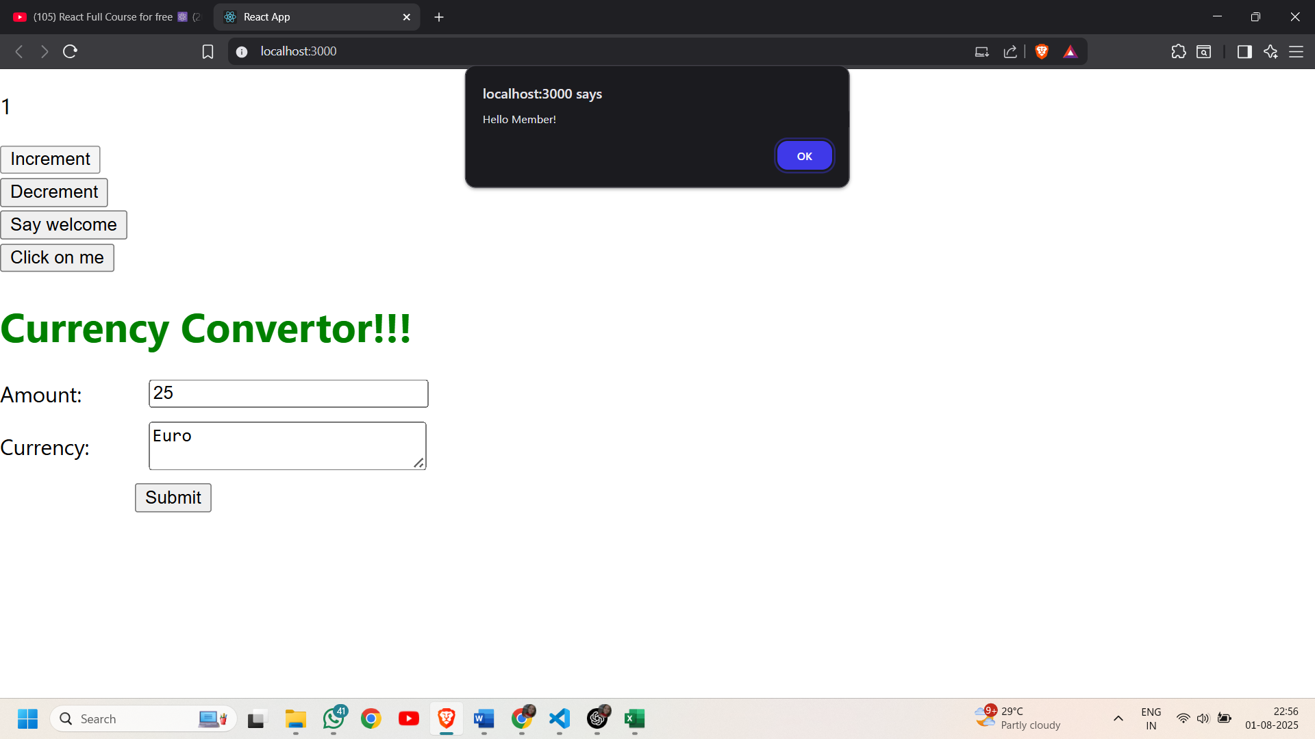
After clicking on say welcome:
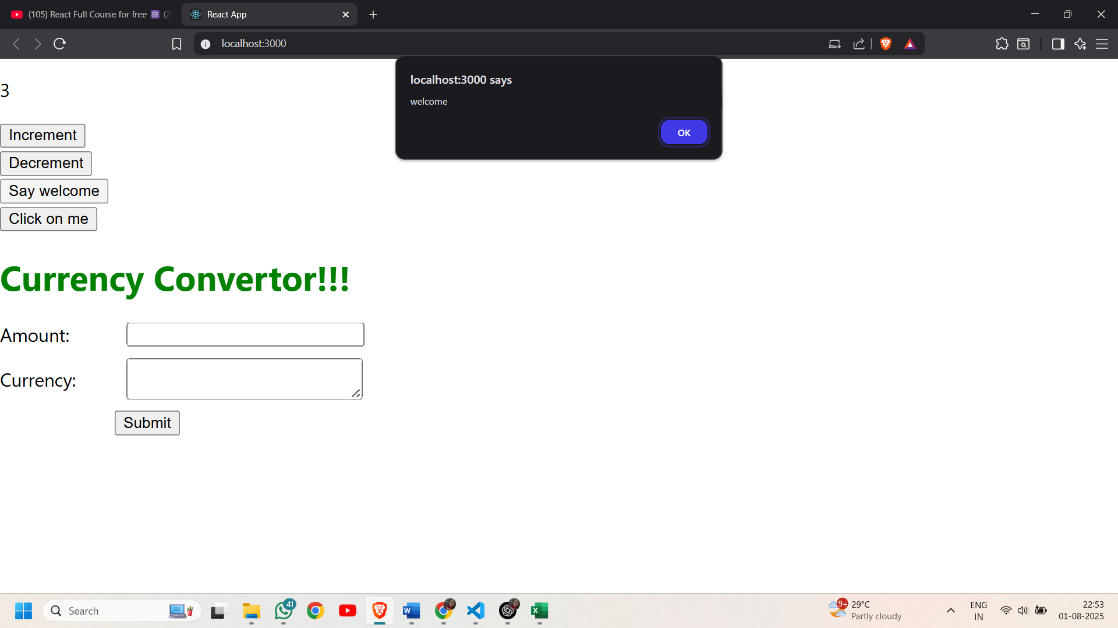
After clicking on the button “click on me” (synthetic event handler)
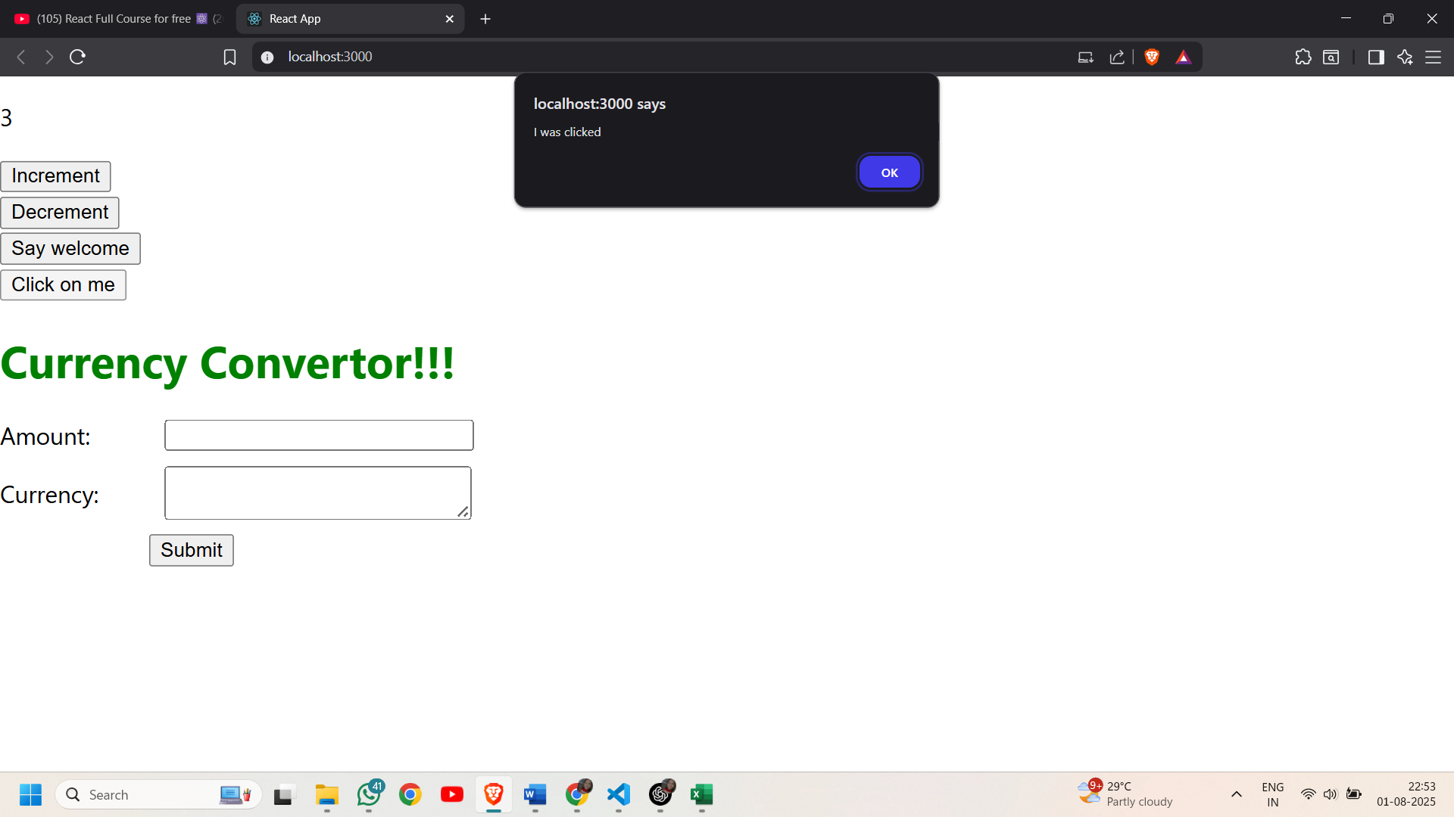
Currency Conversion:
